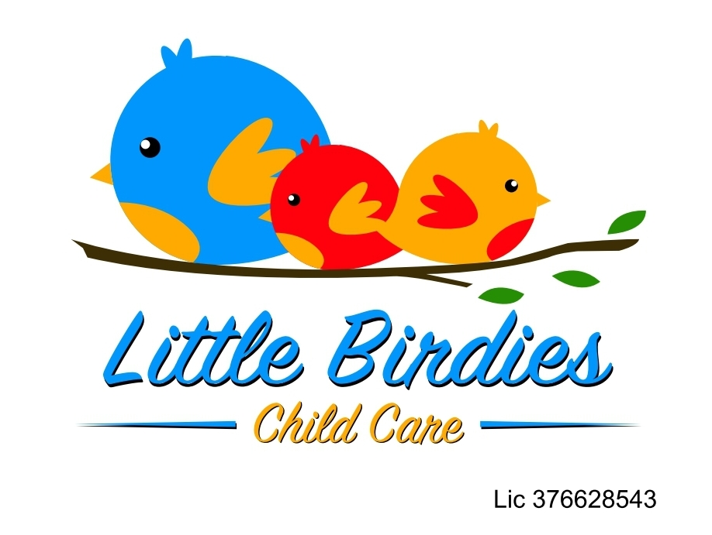
2023 Parent-Provider Contract

DOES YOUR CHILD HAVE ANY FOOD ALLERGIES? If yes, please list: ___________________________________________________________________

I agree to enroll my child, _____________________ in the Little Birdies Childcare Program beginning _________________________.
- Care will normally begin at _____:_____am/pm and end at ______:______ am/pm on the following days of the week:_______________________________________________________________.
- Parents are to provide the following:
*lunch and/or bottles for infants *extra change of clothes/ blanket *diapers and wipes for infants
(Breakfast and both morning and afternoon snacks will be provided by Little Birdies)
- Payment to the provider in the amount of ________ will be made at the beginning of care (drop-off time) in the following manner:
_____ Weekly _____ Bi-weekly ____Monthly _____CDA program ____YMCA program (please check one)
*A late fee of 20.00/day will be added if payment is not submitted by the agreement stated in this contact.
If a check is bounced, you will be charged 50.00**
- Little Birdies Child Care closes promptly at 5:00pm. Any child who is here past closing hours, will be charged $10.00 up to the first 5 minutes late. Anything longer than 5:05pm will result in a $20.00 fee NO EXCEPTIONS. This fee will be billed to you and will need to be paid at the beginning of the following week in addition to the childcare payment. If late and we make several attempts to contact you with an ETA and no response, we reserve the right to contact the CVPD to arrange pick up after 5:50pm.
- In the event there is a holiday we are observing, or if your child will be absent due to any circumstance (including illness), you will still be charged the tuition rate. This also applies to any COVID-19 case.
- In the event of a family vacation or scheduled day off you must notify the provider two weeks in advance. Family vacation or time off requires you to pay 50% of child’s tuition per week to secure your child’s spot here at Little Birdies. Failure to provide a written notice will result in full payment still due. Family vacations are limited to 2 weeks (10 days) per calendar year. This only applies to FULL TIME enrollment. Little Birdies vacations are UNPAID for FULL TIME enrollment only
- If you decide to un-enroll your child or make any changes to your contract in the Little Birdies program, you must give the provider a 2-week notice. In the event of not giving a 2-week notice, you will still be charged for the remainder of the notice given.
- SICK POLICY: Here at Little Birdies Child Care, your child’s health is one of our top priorities! Any child who has a fever of 100 or higher MUST be 24 HOURS clear of fever (without medication) in order to return to school. Any child who is ill and is taking ANTIBOTICS must be 24 hours on the antibiotics before they can return to school. Any child with LICE must be 100% clear of lice AND eggs before returning to school. Any child with VOMITING or DIARRHEA must be 24 hours symptom free before returning to school. Any child with PINK EYE must be free of pink eye and discolored mucus for 24 hours before returning to school. COVID-19: IN THE EVENT YOUR CHILD TESTS POSITIVE FOR COVID-19, THE CHILD MAY NOT RETURN TO SCHOOL UNTIL PROOF OF NEGATIVE TEST RESULT IS GIVEN TO THE PROVIDER & SYMPTOM FREE.
- If the provider must close down due to exposure or positive case of COVID-19 in their own household, 25% of the child’s tuition is still due. This is due to the re-occurring costs of the daycare facility.
- Provider is entitled up to 3 days of paid personal time off for the entire year and will give the best notice she can if able to

By signing below, I acknowledge the following:
- I have read the Parent/Provider Contract and understand and agree with the policies, procedures, and regulations set forth.
- All employees of LBC are mandated reporters and are legally obligated to notify the Department of Health and Human Services in the event of a questionable situation.
- Each family will have a two week probationary period before their spot is permanent. Provider has the right to end child care services. After one week of unexcused absences, a spot can be dropped.
- I release Little Birdies Child Care, it’s staff and all individuals involved from the responsibility of damages/injuries incurred while my child is participating in the day care program.

___________________________________ _________________________________
(Parent signature) (Provider’s signature)
____________________________________ _________________________________
(Date Signed) (Date Signed)

